

Football Player Segmentation and Classification
  - Final Project Report

  - Asma Massad
  - Course Name: Computer Vision
Football Player Segmentation and Classification

Introduction
Semantic segmentation is a computer vision task that aims to assign a label to each pixel in an image. Unlike other image recognition tasks that classify the entire image or detect objects within it, semantic segmentation provides a detailed understanding of the image at a pixel level.
It involves training deep learning models, such as convolutional neural networks (CNNs), to learn and recognize complex patterns and features in images. Through the use of advanced architectures like U-Net, or DeepLab, semantic segmentation has achieved remarkable results in diverse applications, such as autonomous driving, image and video editing, object detection, and scene understanding.
The ability to precisely outline objects and regions of interest in an image has opened up exciting possibilities for numerous computer vision tasks, contributing to advancements in areas like robotics, medical imaging, and augmented reality.
One application that we can utilize the outcomes of sematic segmentation is football match analysis, like players identification and exclusion from the background, also we could further use multiclass segmentation where we can identify the teams of the players.
In this project we used deep leaning based sematic segmentation algorithm (UNet) to detect the players at a pixel level. Also, we provided additional information about the players role and team and football field side in each image, based on traditional computer vision techniques. Finally, we used a pretrained deep learning for human pose estimation called MoveNet to show a skeletal key-point data on the players on each frame, which could be used in future work for further analysis.
The dataset we used provided 512 images from a football match and a json file contains annotations with pixel-level binary masks that indicate the player's location and segmentation boundaries.

2. Methodology
We ---- Following Tasks:
- Multiclass Mask Generation.
- Training A Multiclass Unet Algorithm.
- Player Role Classification.
- Ball Possession Estimation.
- Player Pose Estimation.
We will discuss the details about our approach with each task in the following subsections.

2.1 Multiclass Mask Generation
We generated new masks using the binary masks provided by the dataset, where we colored the players according to their teams. For the blue team (Team A), we generated blue masks for team A players and set the rest of individuals and the background to black. As for the red team (Team B) we colored the mask with red. And the combined both masks to create a multiclass mask.
We also generated mask for the referees, and goalkeepers from both teams, however we did not add these masks to the final mask, because they caused problems with UNet performance. One of the problems is that the goalkeepers and the referees are not present in each image and if we set the number of classed to 5 with UNet, the algorithm will try to assign all 5 classes to pixels in the image. The Other problems, is that team B goalkeeper’s outfit color is very close to the referee’s outfit.
We generated the multiclass masks as follows:
- Background Subtraction
The provided binary masks were used to remove the background from the images. This was done using ‘bitwise_and’ function from OpevCV.
- Extract Teams Colors
We first set a center color for each team, which is the color that we think the team’s outfit contains pixels with colors close to it within a distance that we provided. The center colors were decided manually after inspecting multiple images using photoshop.
The center colors were as follows (RGB color space):
- Team A = [129, 239, 252]
- Team B = [170, 25, 50]
- Referee = [30, 50, 90]
- Goalkeeper A = [110, 220, 150]
- Goalkeeper B = [75, 65, 90]
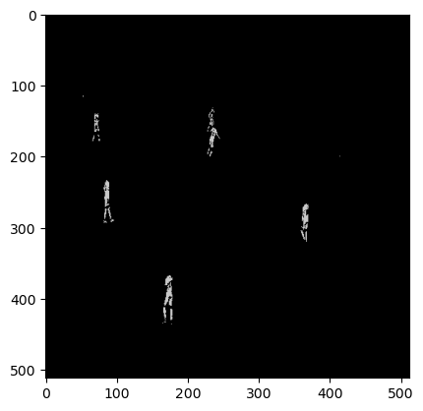
To extract the pixels with a certain distance from the center color, Euclidian distance, the al the extracted pixels where recolored with one gray color, where each class has it own gray color. The output from this step in in figure 1.
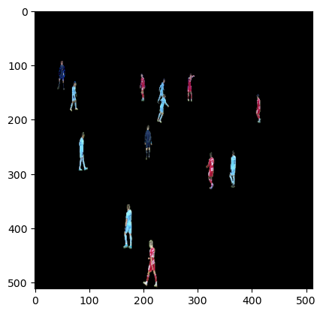
Figure 1: (a) The original masked image (b) The extrated pixles from team A
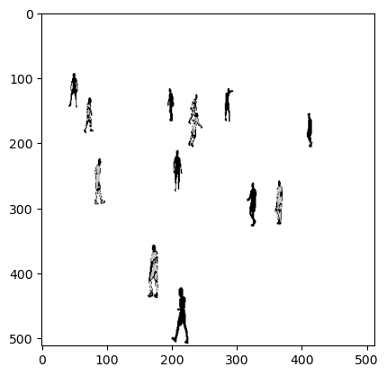
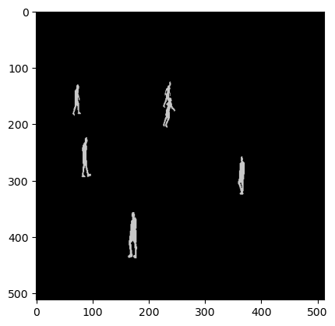
We then combined the image in Figure 1-b with the inverted binary mask to get the shape outline of the players as seen in figure 2-a. The next step was to recolor the shape outline with the gray color of the class. To find the shape outline against the background we used the function ‘label’ from scipy library, each player region was stored in an array. Finally, each region was checked if it has gray pixels above a threshold and recolored the entire region with gray color. Figure 2-b present the final mask for team A
Figure 2: (a) The extraceted pixels from team added with the Inverted mask (b) The final mask for team A

- Final Multiclass Mask
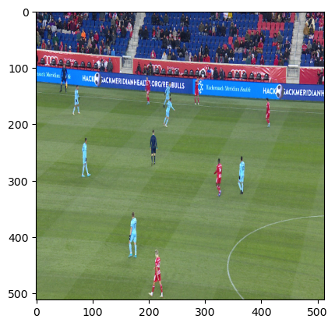
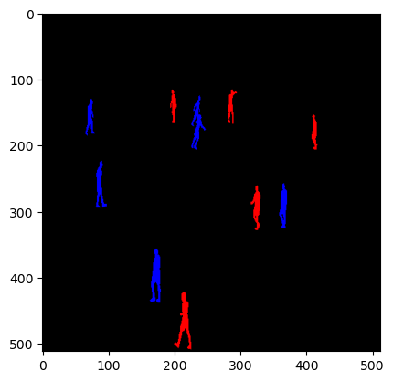
The final step was to re color each class with a more distinguishable color (blue for team A, and red for team B) then combining both masks into the final mask, figure 3 shows the final mask.
Figure 3: (a) The original Image (b) The final mask
The masks were used in two tasks, UNet multiclass segmentation, and player role and team classification.

2.2 UNet Multiclass Segmentation

2.3 Player Role Classification
Since we do not have enough information about the match or the teams playing, we had to make some assumptions and simplifications about the players roles. We noticed that the images from the match where either from the left side of the field (Team A side), right side (team B side) or from the center of the field, so we came up with following assumption about the player role with respect to the field side and his specific position within the image.
First the field side in the image is decided (left, center, or right), then the image is divided into 3 parts: part-1 where x< 170 , part-2 where x is between 170 and 340 and part-3 where x is greater than 340. We chose these number because the image size we are using is (512 x 512). Then we assigned the roles as follows:
- Left side of the field: For team A, if the player is located before x=340 then he is Defender (D), else he is Midfielder (M). For team B if the player is located before x=340 then he is Forward (F), else he is Midfielder.
- Center of the field: For team A before x=170 the player is Midfielder; else he is Forward. For team B before x=340 he is Forward, else he is Midfielder.
- Right side of the field: For team A before x=170 the player is Midfielder; else he is Forward. For team B before x =170 the player is Midfielder, else he is Defender.
The assumption about player roles according to their position in the field is illustrated in figure 4.

Figure 4: Player Role According to their position in the field (Blue is team A, Red is team B).

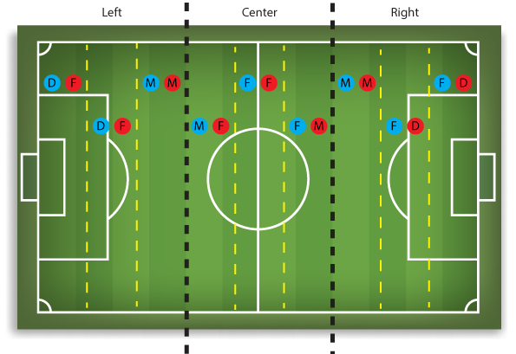

To detect the side of the field in the image, we utilized the lines on the field, we used Hough transform to detect the lines in the field. To make the line detection more accurate and to exclude any lines outside the field we created a mask using color thresholding around two values for RGB green color.
Then according to the detected lines slope we decided the field side. Usually, Hough transform produces multiple lines, so for each line we calculate the slope. If it is negative and between the value -3 to -100, then the field side is left, if the slope is positive between 3 and 100, then the side is right and if the slope between -0.5 and 0.5 (horizontal line) or above 100 or below -100 (vertical line) then the view is from the center of the field.
The classification for each line in the image is stored and the most frequent classification is considered the side of the field.

2.4 Ball Possession
We used a very simple approach, we assumed if the image shows the left side, then the team B has the ball and if the image shows the right side, then team a has the ball.

2.5 Player Pose Estimation
For Player pose estimation we used a pretrained model called MoveNet. First, we converted the images into a video then we applied the algorithm to the video to show the skeletal key-points for the detected players by the algorithm.

rESULTS AND Discussion
In this section we will present the results of each task, and provide discussion for the results and some of the challenges we faced.
A. UNet Multiclass Segmentation
We will start with UNet Multiclass segmentation results.
B. Player Role and Team Classification
For the player role classification, when inspecting many images, we found the results were accurate most of the time, however when the image showed the goal of either sides at an angle around 45° the classification would give the opposite side. After some inspection we found that when the slope value was between -3 to 3 this problem occurred.
Also, we tried using ‘HoughCircles’ to detect the circles on the field which would help us further in the role classification task, but the results were not accurate and the function kept detecting false circle even when we performed parameters tuning. The detected line and the player role classification is show in figure 5, the first initial letter is the player role (F: Forward, M: Midfielder, D:Defender) and the second initial is for the team.
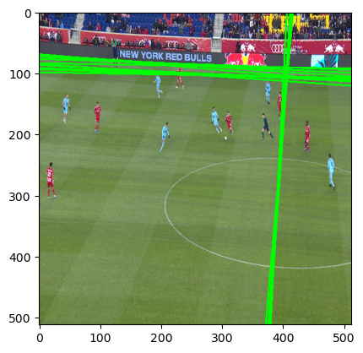
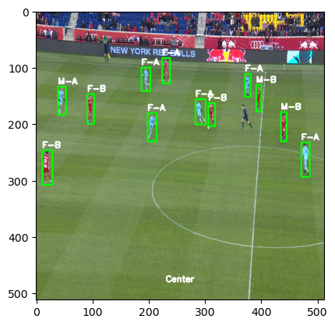
Figure 5: (a) Detected line from Hough transform (b) Player role classification
- Ball Possession
When the side of the field was calculated for all the images, The results show that team A had the ball 37.36% of the time and team B had the ball 62.64% of the time.
- Player Pose Estimation
